Introduction to SOAR - Lab Report

Date: 20/08/2026
Difficulty: Medium
Category: Core SOC Solutions
Platform: TryHackMe

Overview

This lab overviews what a SOAR (Security Orchestration, Automation and Response) tool is and how it helps SOC teams to reduce challenges such as alert fatigue. It also introduces Playbooks and how they can be used to automate investigations and remediations to help analysts.

2. What I did

In typical SOC teams there are various capabilities of a SOC such as monitoring and detection, recovery and remediation, threat intelligence and communication with management and IT teams. However, there are also challenges faced by SOC teams such as alert fatigue, too many disconnected tools, manual processes and a talent shortage. This is where SOAR – Security Orchestration, Automation and Response tool is beneficial to a SOC team. It means analysts don’t need to switch between SIEM, EDR and Firewalls as they can operate them all from within a single SOAR interface. It also adds ticketing and case management features so that incidents can be documented and fixed in a structured way.

Orchestration stops the manual switching between tools such as SIEM to threat intelligence tool to ticketing system which saves time as all these tools are within the SOAR. It defines workflows for investigating types of alerts which are known as playbooks. Automation means no more manual clicks for analysts as it will follow the playbooks itself by automatically checking and verifying key details in the playbook which saves so much time and allows analysts to handle hundreds of alerts without burning out. Response can also be automated by following the playbook to block an IP or disable a user and open a ticket with the details. However, SOC analysts are still needed as SOAR can’t give a judgement call for critical points or understand threats in a business sense.

Playbook Examples:

- Phishing Playbook – Investigating phishing is very time consuming to manually analyse attachments and URLs. SOAR can do this in the background and perform remediation when a positive phishing email is found. THM’s playbook example is below which shows a flow diagram of what to do based on certain conditions.

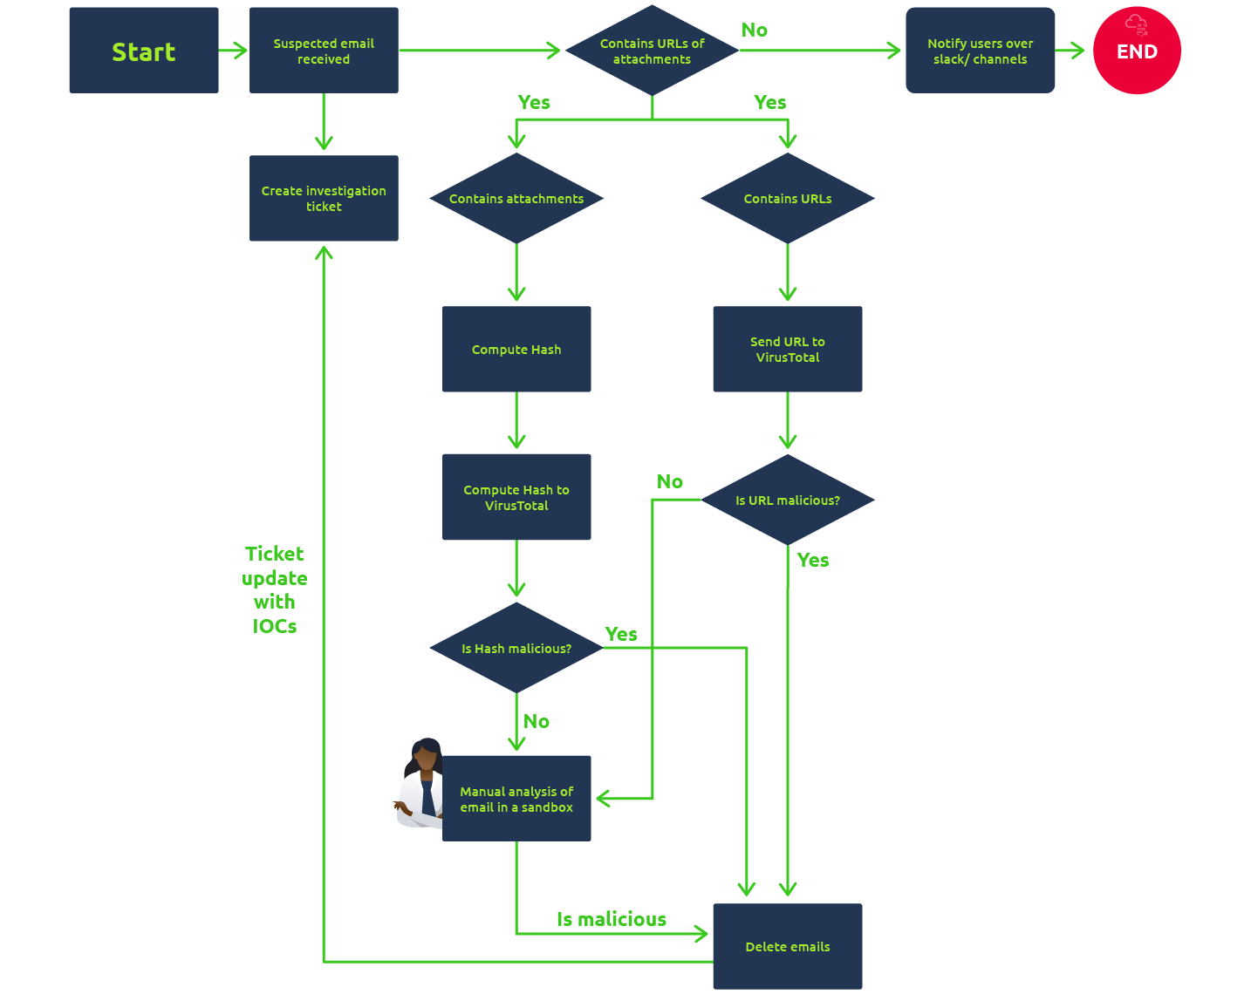

- CVE Patching Playbook – Analysts typically would need to look at new CVEs and remediation plans which can become draining and time consuming. The playbook for this involves analysing the CVE details, assessing the risk, creating a ticket and testing the patch before deployment.

3. What I’ve learned

- Traditional SOC challenges
- What SOAR is
- How SOAR works
- What Playbooks are and how they can be used

